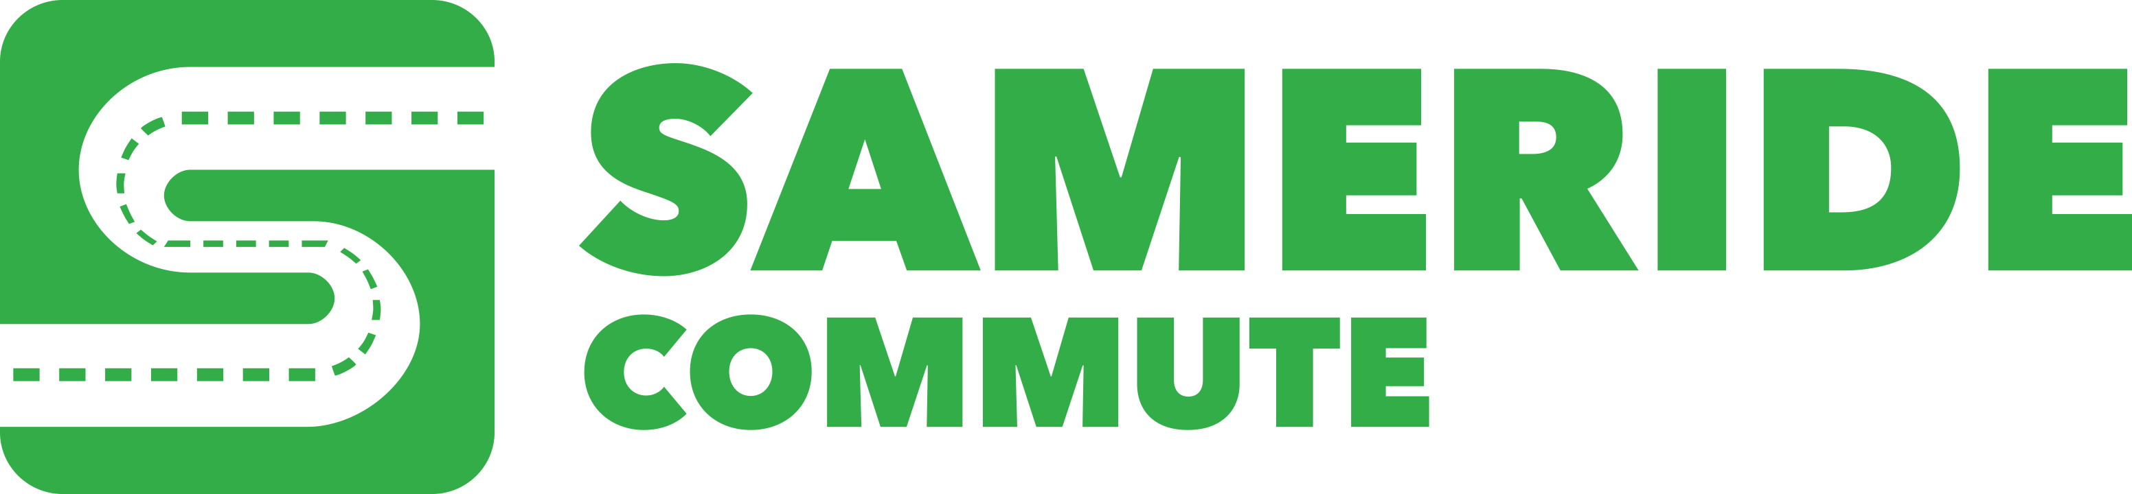
NEWS RELEASE
Sameride  (202) 670-9070, support@sameride.com  www.sameride.com | FOR IMMEDIATE RELEASE  November 12, 2018

Sameride Opens Fredericksburg / Stafford – Arlington / DC Commute Route

Free Sameride Commute App Helps Find a Carpool for Faster Commute on I-95/495/395/66 Express Lanes and SR 267 Toll Road
WASHINGTON, DC, November 12, 2018 – Sameride has opened a new commute route between residential areas of Fredericksburg and Stafford, VA and employment centers in Arlington, VA and Washington, DC with over 400 commuters registered.
Sameride is an on-demand carpool service helping connect drivers and riders commuting on the same route. Often neighbors who happen to work in the same location agree to ride to work together. Sameride app opens up a much larger commute sharing space.
Sameride Commute mobile app, for iOS and Android, allows commuters offer or request rides to ensure that a rideshare is available before their commute. Sameride App user can choose to be a driver or a rider, set their pick-up time and locations, create ride offers or requests a few hours or a few days before their commute. No long-term commitments or established carpool schedules are needed. Using the app, drivers commute toll-free on HOT express lanes and riders benefit from getting a fare-free commute between Park & Ride Commuter Lots and their offices. Both parties benefit from getting to the office and back faster.
Sameride estimates that the app users who commute between Route 3 / Gordon Road Commuter Lot in Fredericksburg, VA and Rosslyn Metro Station in Arlington, VA save up to 24 hours of commute time and either $400 on rider's fares or $800 on express lanes tolls per month. The app users who commute between Route 3 / Gordon Road Commuter Lot and Washington, DC can save up to 25 hours per month and $420 on rider's fares or $820 on express lanes tolls.
The first route that Sameride opened in the Washington, DC Metro Area is Woodbridge, VA – Tysons Corner, VA, which currently serves over 260 commuters.
"Sameride Commute App turns a 1.5-hour exercise of frustration into a breezy 32-minute FREE commute in the express lanes!", says Laura who commutes on Sameride's Woodbridge – Tysons route.
"Brilliant idea, thanks for setting this up. I signed up and placed a request. Thanks!", says Joy who joined Reston – Arlington / DC route.
The Sameride Commute App helps commuters (drivers and riders) take advantage of HOV and HOT express lanes along the I-95/495/395/66 and SR 267 corridors for faster and more cost-effective commutes.
According to Andriy Klymchuk,a company representative for Sameride: “With Sameride Commute App, our commuters are able to get to office and back faster and less expensively compared to driving alone on a regular road or paying express lanes tolls and fares. The Sameride solution complements “slugging”, a casual carpooling, allowing to bring pick-up/drop-off locations closer to commuters offices and homes as well as to carpool outside of regular ”slugging” hours...”
Sameride team combines over 50 years of experience in transportation, marketing, software development and community management. It is united around the goal of bringing technological innovations into commuting.
Free and faster commute on express lanes with Sameride Commute App for on-demand carpool https://www.sameride.com/
# # #
If you would like more information about Sameride and Sameride Commute App, visit www.sameride.com or contact Sameride at (202) 670-9070 or support@sameride.com

